Sunday | Monday | Tuesday | Wednesday | Thursday | Friday | Saturday
 |  |  | 1 | 2 | 3 | 4
5 | 6  Purim Begins | 7 | 8 | 9 | 10 | 11
12  Daylight Saving Time Begins | 13 | 14 | 15 | 16 | 17  St. Patrick’s Day | 18
19 | 20  Spring Begins | 21 | 22  Ramadan Begins | 23 | 24 | 25
26 | 27 | 28 | 29 | 30 | 31

May The Luck of The Irish Be  With You Today and Everyday |  |  | 9:00 Morning Announcements  9:30 Room Visits  10:30 Group Exercises  1:30 Monthly Gazette  3:15 Yahtzee | 9:00 Morning Announcements  9:30 Room Visits  10:30 Word Puzzles  1:30 Baking Treats  3:15 Card Games of Choice | 9:00 Morning Announcements  9:30 Room Visits  10:30 Group Exercises  1:30 Smile, You’re On Candid Camera  3:15 Warm Drinks and Enjoying our Treats |   Pound Cake Day
  Spring Breakers Day | 9:00 Morning Announcements  9:30 Room Visits  10:30 Group Exercises  1:30 UNO  3:15 What Am I? | 9:00 Morning Announcements  9:30 Room Visits  10:30 UNO  1:30 Bingo (Dining Room)  3:15 Yahtzee | 9:00 Morning Announcements  9:30 Room Visits  10:30 Group Exercises  1:30 Manicures and Card Games  3:15 Trivia | 9:00 Morning Announcements  9:30 Room Visits  10:30 What Happened on This Day  1:30 Guess The 60’s TV Show Theme Song!  3:15 Cool Carnations | 9:00 Morning Announcements  9:30 Room Visits  10:30 Group Exercises  1:30 Movie and Popcorn  3:15 Cards of Choice | “Don’t Worry,  Be Happy” Day  
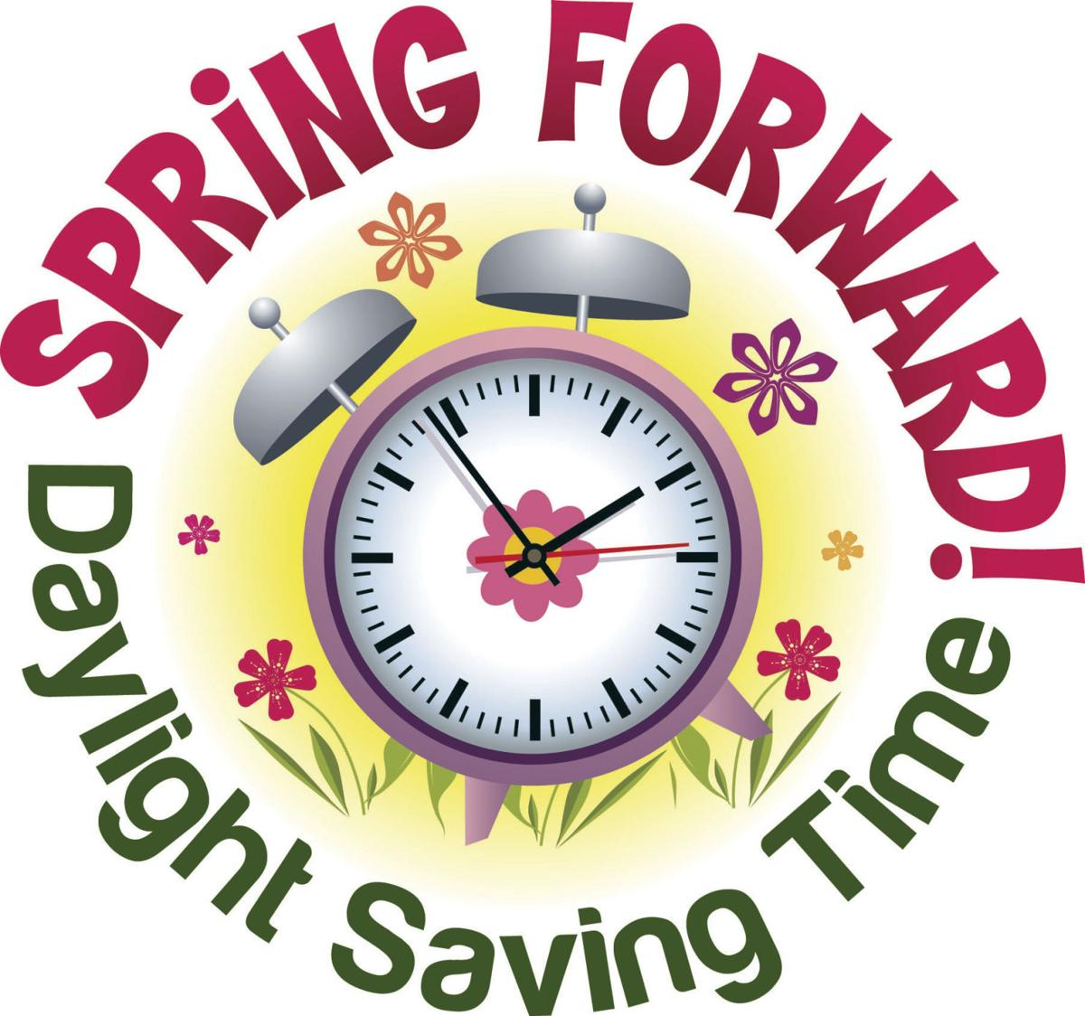 | 10:30 Cards of Choice  1:30 Movie and Popcorn  3:15 Yahtzee | 9:00 Morning Announcements  9:30 Room Visits  10:30 What Am I?  1:30 Toss a Tune  3:15 UNO | 9:00 Morning Announcements  9:30 Room Visits  10:30 Group Exercises  1:30 Bingo (Dining Room)  3:15 Learning About The Life of The Rare Panda | 9:00 Morning Announcements  9:30 Room Visits  10:30 Colouring or Crafting  1:30 Enjoying Barbra Streisand-One Voice Concert  3:15 Yahtzee | Wear Green Day  9:00 Morning Announcements  9:30 Room Visits  10:30 Group Exercises  1:30 Having Fun With Limericks  3:15 Leprechauns on the Loose | 
 | 9:00 Morning Announcements  9:30 Room Visits  10:30 Group Exercises  1:30 Bingo (Dining Room)  3:15 Enjoying the Amazing Birds of Paradise | 9:00 Morning Announcements  9:30 Room Visits  10:30 Manicures and Card Games  1:30 Virtual Farm Tour - JoBo Holstein Farm  3:15 Ag Appreciation Month | 9:00 Morning Announcements  9:30 Room Visits  10:30 Group Exercises  1:30 Modern Jeopardy Trivia  3:15 Cards of Choice | 9:00 Morning Announcements  9:30 Room Visits  10:30 Daily Chronicles  1:30 UNO  3:15 What Happened on This Day | 9:00 Morning Announcements  9:30 Room Visits  10:30 Group Exercises  1:30 Movie and Popcorn  3:15 Yahtzee | 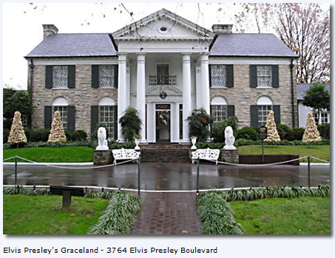  Graceland Day
  Spinach Day | 9:00 Morning Announcements  9:30 Room Visits  10:30 Group Exercises  1:30 Word Wheel  3:15 Golf Card Game | 9:00 Morning Announcements  9:30 Room Visits  10:30 Toss A Tune  1:00 Resident Council  1:30 Food Committee  2:00 Yahtzee  3:15 Head Banz | 9:00 Morning Announcements  9:30 Room Visits  10:30 Group Exercises  1:30 UNO  3:15 Warm Drinks and Chit Chats and Playing a Card Game | 9:00 Morning Announcements  9:30 Room Visits  10:30 Scrabble  1:30 Bingo (Dining Room)  3:15 Bean Bag Toss | 9:00 Morning Announcements  9:30 Room Visits  10:30 Group Exercises  1:30 Going on An African Safari Hunt  3:15 Reminiscing About our Hobbies   | “Winds of March,  we welcome you; There is work for you to do. Work and play and blow all day;  Blow the Winter wind away.” ~ Author Unknown

Beattie Manor Retirement Residence (519) 693-693-4901 tbalint@beattiemanor.com

